FOR STUDENTS
Emission Spectroscopy: Biophysics and FRET

Goals: (1) Determine the free energy associated with unfolding a protein
(2) Understand principles of quenching via Förster energy transfer
(3) Calculate intramolecular distances for partially unfolded and fully folded structures

Resources: Handouts from Lakowicz (chapter 13) (1), Jones (2), and Pace (3).

Introduction and Background

The study of biological macromolecular structure has become a major field in biochemistry and chemistry research laboratories. Different spectroscopic techniques, such as UV-Vis absorption, fluorescence, and circular dichroism, have been employed to investigate the thermodynamics and structural changes associated with protein folding and unfolding. In undergraduate laboratories, most experiments rely on one technique to study a chemical problem. Here, we describe a multifaceted approach towards the study of the important biophysical problem of protein folding. Specifically, the combination of absorption, fluorescence, and Förster resonance energy transfer (FRET) techniques will provide complementary and indepth information on structural changes and thermodynamics associated with these changes. The protein used in this experiment is a well-studied system, cytochrome c (cyt c). Cyt c will be unfolded chemically via a denaturant and monitored spectroscopically.
FRET is a spectroscopic technique that may be used to determine inter- or intramolecular distances. It has been applied to study a wide variety of systems to obtain structural information. FRET occurs via long-range dipole-dipole interactions between donor and acceptor molecules, and does not involve emission of a photon. Radiationless energy transfer from an excited-state donor to a ground-state acceptor is the fundamental principle behind FRET. A critical requirement for FRET is spectral overlap between the emission spectrum of the donor and the absorption spectrum of the acceptor. The efficiency of FRET energy transfer is inversely proportional to the sixth power of the distance between the donor and acceptor. By utilizing this distance dependence, structural information about proteins can be obtained during denaturant-induced unfolding.
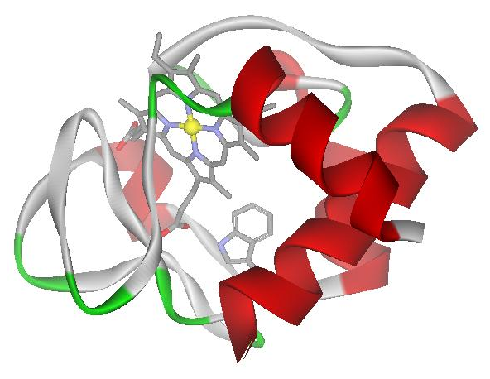
Cytochrome c is an electron transfer protein found in the inner membrane of mitochondria. This globular protein consists of a single polypeptide chain that contains one tryptophan residue at position 59 (Trp-59) and a covalently bound heme cofactor. The intrinsic fluorophore, tryptophan, serves as the FRET donor while the heme cofactor serves as the acceptor. In the native structure of cytochrome c, Trp-59 is in close proximity to the heme group (shown on the right). When the protein is folded, energy is transferred from the excited tryptophan to the heme group, causing the tryptophan fluorescence to be quenched. Upon addition of a chemical denaturant to unfold the protein, the rise in fluorescence signal from Trp-59 indicates that the distance between donor and acceptor has increased; this change in distance as a function of folding state can be quantified via the equations that describe FRET.

FRET Theory

According to Förster’s theory on energy transfer, the rate of energy transfer k_{T} is related to the lifetime of the donor in the absence of acceptor (τ_{D}) and the distance between the donor and acceptor (r) via

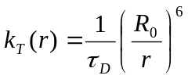 (1)

The Förster distance, R₀, is the critical distance for energy transfer, and is defined as the distance at which the efficiency of energy transfer is 50%. Förster distances typically range from 20-60 Å, and can be calculated using the relationship

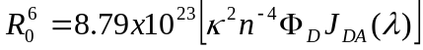 in Å⁶ (2)

where κ ² is the orientation factor between the transition dipoles of the donor and acceptor, n is the refractive index of the solvent, Φ_{D} is the quantum yield of the donor in the absence of acceptor, and J_{DA} is the overlap integral of the donor emission spectrum and the acceptor absorption spectrum. The overlap integral can be calculated as follows:

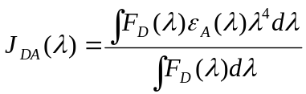 (3)

J_{DA} is in M⁻¹cm³, F_{D}(λ) is the fluorescence of the donor in absence of acceptor, and ε_{A}(λ) is the extinction coefficient of the acceptor at λ. FRET energy transfer efficiency, E, is defined by the following relationship:

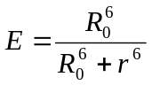 (4)

Efficiency can be experimentally determined using the fluorescence intensities of the donor with and without the acceptor in the form of Equation 5:

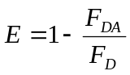 (5)

where F_{DA} is the fluorescence intensity of the donor in the presence of the acceptor, and F_{D} is the fluorescence intensity of the donor in the absence of the acceptor.

Free energy of Protein Unfolding

Native tertiary structures of biomolecules can be disrupted by a variety of methods, including changes in temperature and pH, as well as addition of chemical denaturants. Two common chemical denaturants, guanidinium hydrochloride and urea, are used to disrupt native protein structures easily. The mechanisms by which these denaturants unfold proteins is an active area of research, and hypotheses regarding their modes of action involve direct solvation of peptide bonds and other hydrophobic regions as well as significant modification of solvent structures. By measuring the relative concentrations of folded and unfolded proteins as a function of denaturant concentration, one generates an unfolding curve which can be further analyzed to determine protein stability.
Spectroscopic techniques are commonly used to determine relative concentrations of folded and unfolded proteins for a given denaturant concentration. A critical requirement is that the folded and unfolded species exhibit unique spectroscopic signatures. Typical optical methods that may distinguish between native and denatured structures include circular dichroism, UV-Vis absorption spectroscopy, and fluorescence spectroscopy. Shifts in absorption/emission maxima as well as changes in intensities often reflect changes in global and local protein structures. By utilizing these spectroscopic shifts to monitor changes in population, unfolding curves can be generated to yield free energies of unfolding in the absence of denaturant.
The simplest model of protein folding/unfolding describes a two-state system of folded (F) and unfolded (U) species:

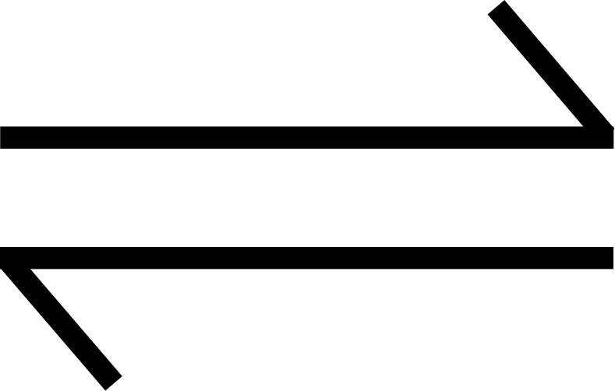
F U (6)

The equilibrium constant and free energy of unfolding are then given as

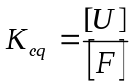 and 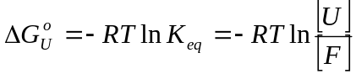 (7) and (8)

where 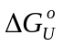 is the free energy of unfolding in denaturant. Here, we are interested in the free energy of unfolding in the absence of denaturant. A theoretical treatment described by Pace (1984) and Jones (1997) approximates a linear perturbation of free energy as a function of denaturant concentration wherein extrapolation of this relationship to zero denaturant concentration gives rise to the free energy of unfolding in the absence of denaturant, 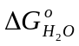:

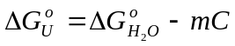 (9)

Here, m (kcal M⁻¹ mol⁻¹) describes the rate of change of the free energy of denaturant with respect to denaturant concentration and C (M) is the molar concentration of denaturant.
The denaturant concentration that gives rise to equal populations of folded and unfolded proteins is referred to as the midpoint concentration, C_{m}. At C_{m}, the free energy of unfolding is zero so that
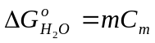 (10)

Using the definition of fraction of unfolded molecules, f, given by:

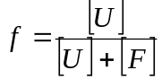 (11)

it is relatively straightforward to obtain the following equation:

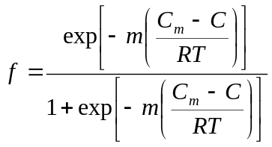 (12)

Experimental data points in an unfolding curve are fit to Equation 12, with f and C as dependent and independent variables, respectively, to yield values for m and C_{m}. Knowledge of the variables m and C_{m} then allows for determination of the free energy of unfolding in the absence of denaturant, , using Equation 10.

Lab procedure

In this experiment, you will determine the free energy of unfolding ferric cyt c using the chemical denaturant urea. You will monitor changes in fluorescence from Trp-59 as a function of urea concentration to generate an unfolding curve for cyt c (part A). In part B, you will determine the Förster distance of the trp-heme pair using a tryptophan model compound, n-acetyl-tryptophanamide, to approximate the donor in absence of acceptor (F_{D}). The cyt c absorption spectrum is used to determine ε_{A}(λ) of the acceptor. Finally, in part C, you will combine the knowledge gained in parts A and B to determine changes in distance between Trp-59 and the heme moiety as a function of denaturant.

Instruments: Follow lab manual instructions for the fluorometer and absorption spectrometer.

A. Measurement of unfolding curve
1. Turn on the instrument immediately upon arriving in the laboratory.
2. Prepare a stock solution (50 mL) of 20 mM pH 7.4 phosphate buffer. This buffer is called KP_{i}. Both components of the conjugate acid-base pair should be weighed out separately to obtain the desired ratio and then dissolved in water. Use potassium phosphate monobasic (CAS 7778-77-0) and potassium phosphate dibasic (CAS 7758-11-4).
3. Prepare a stock solution (50 mL) of 10.0 M urea (CAS 57-13-6) in KP_{i}. You should add the urea and phosphates to an empty graduated cylinder and add water up to 50 mL. This solution is called urea/KP_{i}.
4. Prepare a stock solution (0.8 mL of about 500 μM) of cyt c (CAS 9007-43-6) in KP_{i} (ε₄₁₀ for cyt c in this solution is approximately 105,000 M⁻¹cm⁻¹, ε₅₃₀ is 11,200 M⁻¹cm⁻¹).
5. Prepare several ~ 10 μM cyt c (1.5 mL each) samples by mixing the appropriate amounts of stock solution made in part A4 with stock solutions made in parts A3 and A2 to achieve final urea concentrations of 0.0 to 10.0 M in 0.5 M increments. You should have 21 samples in 21 plastic Eppendorf tubes.
6. Record fluorescence and absorption spectra of KP_{i}, urea/KP_{i}, and each of the 21 samples prepared in part A5. The fluorescence spectra should be recorded with 290 nm excitation, and scanned from 305 nm to 500 nm. Use “high” sensitivity and 5 nm bandpass for both excitation and emission. These spectra will be used to determine the free energy of unfolding of cyt c using fluorescence changes of Trp-59 as the probe. You will see a large peak at ~323 nm in spectra of the buffers KP_{i} and urea/KP_{i} as well as in some of your cyt c samples. Talk to the Professor or TAs to understand the origin of this peak.
7. To obtain an unfolding curve, subtract background fluorescence spectra of the buffers KP_{i} or urea/KP_{i} from corresponding fluorescence spectra of protein to obtain a corrected fluorescence spectrum. These corrected fluorescence spectra should be made using the general procedure:
Spectrum A = raw fluorescence from cytochrome c in buffer/denaturant
Spectrum B = raw fluorescence from buffer/denaturant
Corrected Spectrum = Spectrum A - B
The fluorescence intensity of the corrected spectrum at 350 nm should then be normalized for protein concentration (via the absorption value at 530 nm), and plotted as a function of urea concentration. The y-axis should be scaled from 0 to 1 (max). What is the free energy of unfolding? You will need Equations 10 and 12. Fitting your data to Equation 12 is best accomplished with advanced analytical software, such as Matlab or Igor Pro. You may also use the “Solver” tool in Excel.
8. If time permits, note the change in absorption spectra as a function of unfolding. Plot the shift in Soret absorption near 410 nm as a function of denaturant concentration to generate an unfolding curve and determine the free energy of unfolding for cyt c. How do these results differ from part A7 and what are possible origins of the differences (if any)?

B. Determination of the Förster distance

1. Prepare 5 mL of a ~10 μM solution of the tryptophan model compound, N-acetyl-tryptophanamide (NATA) (CAS 2382-79-8) in KP_{i}. The actual concentration is not important, as long as you are not saturating the fluorometer detector. You may need to start with a concentrated stock solution of NATA and dilute it to the desired ~10 μM. Regardless of how you prepare the sample, you must determine the actual concentration based on the value for the extinction coefficient at 280 nm (ε₂₈₀ for NATA is 5630 M⁻¹cm⁻¹).

2. Measure absorption and fluorescence spectra of the solution prepared in part B1.

3. Use the fluorescence spectrum collected in part B2 along with the absorption spectrum of ~10 μM cyt c (0.0 M urea) from part A6 to calculate the Förster distance of the trp-heme pair. You will need Equations 2 and 3. Determination of the integrated areas can be done numerically by approximating the integral as a sum, or with advanced software such as Matlab or Igor Pro. Other pertinent information: κ²=2/3, n=1.4, Φ_{D}=0.13.

C. Calculation of intramolecular distances for unfolded structures

1. Using Equation 4 and your calculated R₀ from part B3, make a graph of energy transfer efficiency (E) as a function of distance, r, between donor and acceptor. This is the theoretical distance dependence of energy transfer for your donor-acceptor pair.

2. Use Equations 4 and 5 and the corrected and normalized (for concentration) spectra from part A6 to determine the distance between Trp-59 and the heme group as a function of denaturant concentration. For F_{D}, you should use the fluorescence intensity of NATA at the same concentration as the cyt c samples. Compare the distance between Trp-59 and the heme group for the fully folded protein (0.0 M urea) with distances obtained from the known crystal structure (PDB 1HRC). How do these compare?

3. What assumptions are made to determine from part A and intramolecular distances from part C? Do these assumptions conflict?

D. Optional

1. Generate an unfolding curve using 0.0 to 6.0 M guanidinium chloride (gdmHCl) (CAS 50-01-1) instead of urea as the denaturant. Because the pK_{a} of phosphate buffer is sensitive to ionic strength, you must adjust the pH of each cyt c + gdmHCl solution to 7.4 prior to making fluorescence and absorption measurements. How does the measured conformational stability of cyt c, , differ when measured with this other denaturant? What intermolecular forces may impact this difference in thermodynamic stability?

2. Index of refraction may be used for accurate determination of denaturant concentration (4). What are the principles of index of refraction?

Hazards: Urea is a skin irritant; guanidinium hydrochloride is a skin, eye, and respiratory tract irritant. If denaturant comes in contact with any of the above areas, wash with copious amounts of water. General laboratory safety practices should be followed. Gloves, safety glasses, and lab coat should be worn at all times. Care should be taken while handling proteins. While cytochrome c and phosphate buffer are relatively harmless, other proteins and buffers can be potentially hazardous.

E. References

(1) Lakowicz, J. R. Principles of Fluorescence Spectroscopy, 3rd ed.; Springer: New York, 2006.
(2) Jones, C. M. J. Chem. Educ. 1997, 74, 1306-1310.
(3) Pace, C. N. Methods Enzymol. 1986, 131, 266-280.
(4) Shirley, B. A. Urea and guanidine hydrochloride denaturation curves. In Protein Stability and Folding; Shirley, B. A., Ed.; Human Press Inc.: Totowa, 1995; Vol. 40; pp 177-190.

FOR INSTRUCTOR
Emission Spectroscopy: Biophysics and FRET

1. Part A5: In practice, actual denaturant concentrations are typically ~10% different from calculated values. Therefore, if time permits, accurate determination of denaturant concentration should be attempted using index of refraction measurements with a refractometer. The relationship between index of refraction and denaturant concentration (urea or gdmHCl) is provided in the following publication:

Shirley, B. A. Urea and guanidine hydrochloride denaturation curves. In Protein Stability and Folding; Shirley, B. A., Ed.; Human Press Inc.: Totowa, 1995; Vol. 40; pp 177.

2. Part A6: Folded protein exhibits essentially no fluorescence; signal from Trp-59 is ~98% quenched relative to the free model compound NATA. Folded samples show a prominent water Raman stretch. Trp-59 fluorescence in fully unfolded protein is ~50% quenched relative to free NATA. The water Raman stretch is overwhelmed by Trp-59 fluorescence and therefore, indistinguishable, in unfolded protein samples. Typical data collected from a student are shown below.

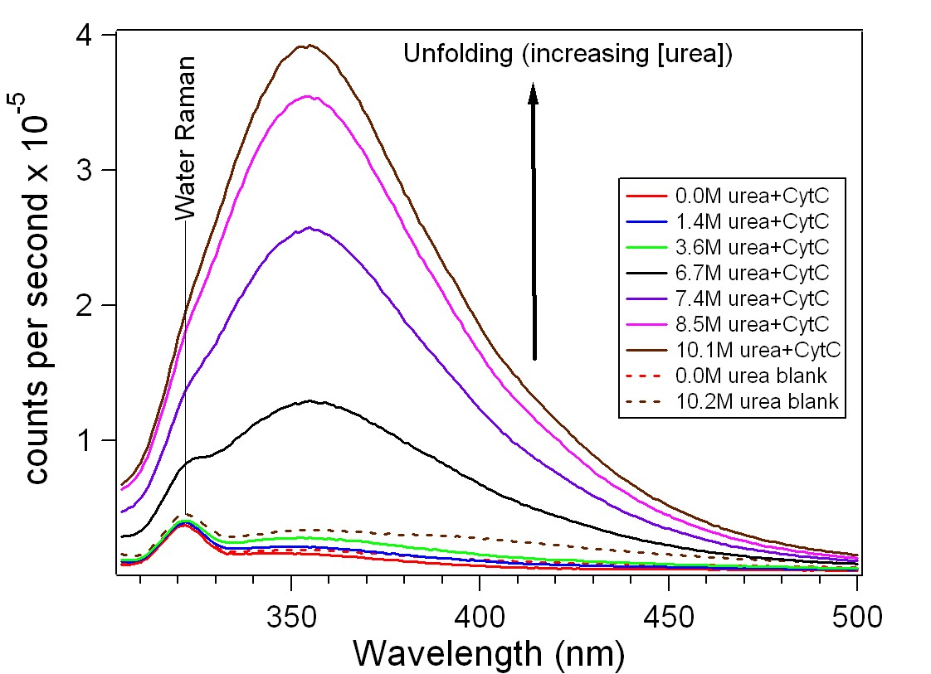

3. The following are typical data collected from four sets of students. Students were evaluated by oral (20-minute) or written reports. Grading consisted of conceptual understanding of FRET and protein folding, calculations, reasonable error analysis, and references. In general, we have found that adequate data can be obtained in this experiment. Students who were unable to obtain reasonable data were primarily graded on qualitative knowledge of the principles of FRET and protein conformational stability and reasonable error analysis of their poor data.

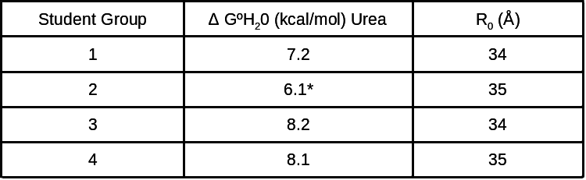
* For this set of students, protein concentrations were too low to obtain the necessary
signal-to-noise ratio, resulting in large errors in calculating ∆Gº_{H20}

4. Parts A7 and B3 require fitting data to a sigmoidal function as well as finding areas under curves. I have encouraged students to use advanced analysis software, such as Matlab or Igor Pro, to independently do the calculations. If advanced software is unavailable, or if students are unable to perform the rigorous calculations on their own, Excel Solver add-in can be used to perform the sigmoidal fit by minimizing the sum of the deviations squared. Detailed instructions on the use of Excel for sigmoidal fitting appear below.

Note: Microsoft Excel Solver add-in must be installed in order to perform this fit. If installed, it will be listed under the Tools drop-down as “Solver…”. See Microsoft Excel Help for information on installing the Solver add-in.

- Input experimental x- and y-axis values (cells A2:A21 and B2:B21 below).
- Enter guess values for the two fit coefficients, concentration midpoint (C_{m}, cell F2) and transition slope (m, cell F3).
- Referencing the x-axis values (denaturant concentration, cells A2:A21) and the guess fit coefficients, generate a column containing model values for fraction unfolded (column C, see Equation 12).
- Generate a column for the deviation between the model values and the experimental values for each point, that is |f_{i,model}-f_{i,experimental}| for all i, where f is fraction unfolded (cells D2:D21).
- Generate a single cell containing the sum of the deviations squared (cell F5).
- Open Solver from the Tools drop-down menu. Set the cell containing the sum of the deviation squared as your target cell. Select “Min” in the “Equal To:” field. Select the cells containing your fit coefficient guesses ($F$2,$F$3) under the “By Changing Cells:” field. Under options make sure “Assume Linear Model” is not checked. Click “OK” and click “Solve” to obtain the fit parameters.
